|  |  |  |  |
| --- | --- | --- | --- |
| Name:  Class: | ____________________________________  ________________ | | Date:_________ |
|  | **Year 11 Essentials**  **Test 2, 2019**  **Topic – Fractions, Decimals, Percentages** | | / 35  % |
| **Total Time:** | *40 min TOTAL* |  | |
| **Weighting:** | *5 %* |
| **Equipment:** | *1 page of notes, calculator* | | |

**NON-CALCULATOR SECTION - 25min**

|  |
| --- |
| **Question 1*****2 marks*** |

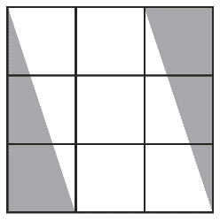What fraction of the shape is shaded, in simplest form?

|  |
| --- |
| **Question 2*****5 marks*** |

Write the fractions marked by a dot on the number line:



|  |
| --- |
| **Question 3** ***2 marks*** |

Write the following fractions in ascending order:

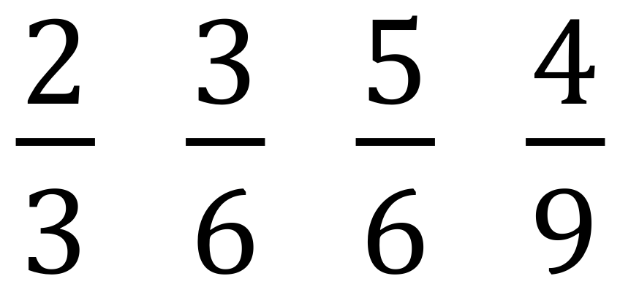

|  |
| --- |
| **Question 4 *10 marks*** |

Evaluate the following. **Make sure to leave all answers as proper or mixed fractions.**

**If possible, simplify your answer.**







|  |  |  |
| --- | --- | --- |
|  |  |  |
|  | **Year 11 Essentials** Name: ____________  **Test 2, 2019**  **Topic – Fractions, Decimals, Percentages** |  |

**CALCULATOR SECTION – 15 min**

|  |
| --- |
| **Question 5 *4 marks*** |

Complete the table:

|  |  |  |
| --- | --- | --- |
| **Fraction** | **Decimal** | **Percentage** |
|  |  | 25 % |
|  | 0.35 |  |
|  |  |  |
|  | 2.19 |  |

|  |
| --- |
| **Question 6 *3 marks*** |

Jakob has 50 apples at the start of the day. At the end of the day he has sold 43 apples.

1. What percentage of apples has Jakob sold?
2. What fraction of apples remain unsold?

|  |
| --- |
| **Question 7 *4 marks*** |

1. In a school of 250 children, 4% were ill with chicken pox. How many children had chicken pox?
2. In a test out of 80 marks, students have to get 45% to pass the test. How many marks do the students need to pass the test?

|  |
| --- |
| **Question 8 *5 marks*** |

1. Mrs. Stretch earns $3500 a month. She saves $280 a month. Savings is what percent of her income?
2. A chemist analyses 28g of an alloy and finds that it contains 7g of tin, 14g of lead and 7g of other metals.
   1. What is the ratio of lead to tin to other metals?
   2. What percentage of the alloy contains lead?
   3. What fraction of the alloy contains lead and other metals?

**End of Test**